System Page — “How it works”
Chart Narrative (Timeline Story)

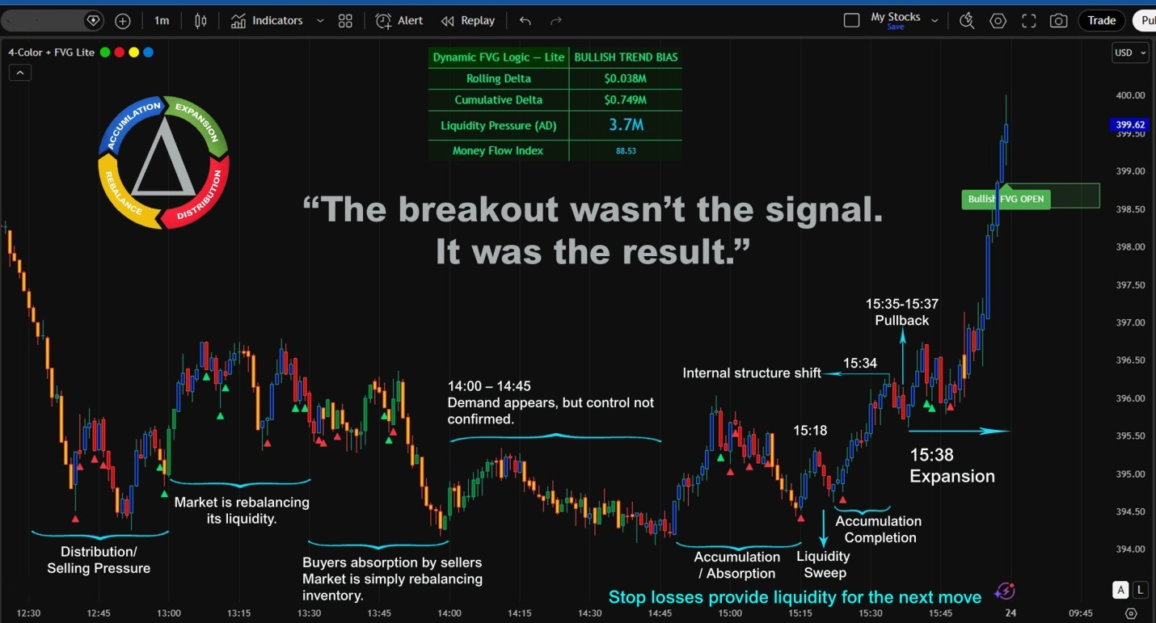

Simple rule for beginners
-  Many Reds → Sellers control market
-  Many Greens → Buyers control market
-  Repeated Blues → Accumulation building
-  Yellow spikes → Liquidity events

How the Colors Tell the Market Story

12:30 – 13:00

Distribution / Selling Pressure
Candle behavior
   dominant
Meaning:
Sellers are unloading positions.
Price forms:
Lower High → Lower Low
Market Bias:
➡ Bearish

13:00 – 13:30

Rebalancing Phase

Candle behavior

 +  +  +  mixed sequence

Example sequence:

 →  →  →  →  →  → 

At first glance this looks random, but it actually reveals a liquidity battle between buyers and sellers.

Step 1 — Buyer Tests the Reaction
 Green — Buyer Response

After the previous sell pressure, buyers try to push the price up.
But the market hasn't confirmed control yet.

Step 2 — Absorption Begins
 Buyers absorb supply.
The price doesn't move strongly because there's still seller inventory.

Step 3 — Sellers Counterattack
 Sellers try to push the price down further.
But if:
The price hasn’t created a new Lower Low
Momentum is weak
→ signs that sellers are weakening.

Step 4 — Absorption continues
 Blue — Absorption
Buyers absorbing selling pressure.
Sellers are still active, but price refuses to break down.
This is the first sign that selling pressure is being neutralized.

Step 5 — Liquidity probe

 Yellow — Liquidity Probe
Yellow is usually a liquidity test.
The market is checking:
Are there any stop-loss orders left?
Are there any orders left to fill?
This is how the market finds fuel for its next move.

Step 6 — Absorption Continues

 Blue — Absorption

Blue candles show buyers absorbing selling pressure.

Sellers are still active, but price refuses to break down.

This is the first sign that selling pressure is being neutralized.

Step 7 — Seller's final attempt
 Sell attempts still appear
However:
- Sellers absorb the demand
- Buyer momentum fails
- Price cannot establish Higher High

This shows:
➡Buyer attempts are absorbed by sellers

Market bias is still weakly bearish.

13:30 – 14:00

 +  +  +  mixed

Continued Rebalancing
Buyers attempt to respond
but sellers still absorb the demand.
Buyers lose defense
→ Price drifts lower while market rebalances supply and demand

14:00 – 14:47

Early Demand
Candle behavior
 +  +  + mixed
Meaning:
Demand begins appearing.
However:
Structure is still sideways.
Buyer control is not confirmed yet.

14:48 – 15:14

 Blue dominant
mixed with
 weak sell attempts
 liquidity probes

Accumulation / Absorption Zone
During accumulation the chart often shows mixed candle colors.
This is normal because buyers and sellers are interacting.
Several metrics begin rising:
• Rolling Delta
• Cumulative Delta
• Liquidity Pressure (AD)

 Blue — Absorption
Blue candles appear when:
• Buyers absorb selling pressure
• Price holds near support or resistance
• Market refuses to move lower
Meaning:
➡ Smart money quietly building positions
This is the core signal of accumulation.

 Red — Sell Attempts
Red candles represent:
• Sellers still trying to push price lower
• Weak bearish attempts
But the key detail:
Price does not continue dropping.
Meaning:
➡ Sellers are being absorbed by buyers
This is exactly what absorption looks like.

 Yellow — Liquidity Probes
Yellow candles often appear when:
• Market tests nearby liquidity
• Small stop hunts occur
• Market searches for orders
Meaning:
➡ Market is probing liquidity inside the range
This helps institutions fill large positions.

15:18 – 15:21 – Liquidity Sweep
Candle behavior
 spike down
long lower wick
Meaning:
Price briefly drops below a recent low.
Stop-loss orders are triggered.
➡ Liquidity gets collected
This liquidity becomes fuel for the next move.

15:22 – 15:34 – Internal Structure Shift
Candle behavior
 followed by 
Meaning:
Buyers begin breaking internal structure.
Momentum begins shifting upward.

15:35 – 15:37

Pullback Confirmation
Candle behavior
Small  pullback
then  support
Meaning:
Market tests whether buyers can defend the price.
Result:
Higher Low forms.
➡ Buyers maintain control.

15:38 — Expansion Phase

Candle behavior

 dominant
with occasional
 and 

This is completely normal during a trend expansion.

Why Red Appears During Expansion

 Red candles here are counter-pressure, not reversal.

They usually mean:

• short-term profit taking
• weak sellers trying to fade the move
• small liquidity grabs

But notice something important:

Price does not break the Higher Low structure.

So the trend remains intact.

Think of these red candles as:

➡ speed bumps in an uptrend

Why Yellow Appears

 Yellow candles are often micro liquidity tests.

During expansion the market still needs:

• new orders
• trapped traders
• liquidity to fuel the next push

So price may briefly:

• dip
• grab stops
• shake weak hands

Then continue upward.

15:41—Breakout
Candle behavior
Strong  impulse
A Bullish Fair Value Gap (FVG) appears.
Breakout traders now notice the move.
But the move was already prepared earlier during:
15:22 → Structure Shift

The Lesson
Price moves last.
Liquidity moves first.
Most traders react to the breakout candle.
The 4-Color Liquidity System shows the behavior building before the breakout happens.
CFE Sequence
Accumulation → Liquidity Sweep → Structure Shift → Buyer Control → Expansion

Tip for New Traders
If you see:
 Blue appearing repeatedly
 Red attempts failing
 Yellow liquidity probes
and price stays sideways
➡ This is classic accumulation behavior.

What the Dynamic FVG Logic Dashboard Revealed
Around this zone:
• Rolling Delta rising
• Cumulative Delta rising
• Liquidity Pressure (AD) increasing
Key insight:
Even though price looks slow, order flow shows buyers building positions.
This is exactly what institutional accumulation looks like.

During accumulation:

Why Price Does Not Move Yet
Smart money does not want price to move yet.
They need time to:
• collect liquidity
• fill large positions
• absorb selling pressure
So price stays sideways intentionally.

The Key Structure Rule

During a bullish expansion you will often see:

 impulse
 small pullback
 liquidity probe
 continuation

As long as price keeps forming:

➡ Higher Lows

the expansion is healthy.

What Would Be a Warning?

Expansion becomes weak if:

•  Red candles start dominating
• Higher Lows break
• Blue absorption appears above resistance

None of that happens in the chart.

So the move at 15:38 is a clean expansion sequence.

Simple Way to New Traders

Expansion does not mean:

 straight up.

Real expansion looks like:

 → → → → →

Small pullbacks and liquidity tests are what keep the trend alive.

